

**Capstone Project Report**

**Report 4 – Software Design Document**

– HoChiMinh, September 2020 –

**Table of Contents**

I. Project Report 4

1. Status Report 4

2. Team Involvements 4

3. Issues/Suggestions 4

II. Software Design Document 5

1. Overall Description 5

1.1 Assumptions 5

1.2 Design Constraints 5

2. System Architecture Design 5

2.1 Overall Architecture 5

2.2 System Architecture 5

2.3 Package Diagram 6

3. System Detailed Design 7

3.1 Register 7

*a.* *Class diagram* 7

*b.* *Sequence diagram (s)* 7

3.2 Login 7

*a.* *Class diagram* 7

*b.* *Sequence diagram (s)* 7

3.3 Search photographer 7

*a.* *Class diagram* 7

*b.* *Sequence diagram (s)* 7

3.4 Get photographer’s detail 7

*a.* *Class diagram* 7

*b.* *Sequence diagram (s)* 7

3.5 Book photographer 7

*a.* *Class diagram* 7

*b.* *Sequence diagram* *(s)* 7

3.6 Review photographer 7

3.7 Get booking (cancel, edit, accept, decline) 7

*a.* *Class diagram* 7

*b.* *Sequence diagram (s)* 7

3.8 Edit working calendar 7

*a.* *Class diagram* 7

*b.* *Sequence diagram (S)* 7

3.9 Get customer’s review 7

*a.* *Class diagram* 7

*b.* *Sequence diagram (s)* 7

3.10 Manage service (add, edit, remove) 7

*a.* *Class diagram* 7

*b.* *Sequence diagram (s)* 7

3.11 Manage album (add, edit, remove) 7

*a.* *Class diagram* 7

*b.* *Sequence diagram (s)* 7

3.12 Manage user (add, edit, remove) 7

*a.* *Class diagram* 7

*b.* *Sequence diagram (s)* 7

3.13 Manage shooting category (add, edit, remove) 7

3.14 Get profile (edit profile) 7

3.15 Logout 8

3.16 Change password 8

4. Class Specifications 9

4.1 XYZ Class 9

4.2 ABC Class 9

4.3 … 9

5. Data & Database Design 10

5.1 Database Design 10

5.2 Data File Design 14

# I. Project Report

## 1. Status Report

|  |  |  |  |
| --- | --- | --- | --- |
| **#** | **Work Item** | **Status** | **Notes (Work Item in Details)** |
| 1 |  | Pending |  |
| 2 |  | In Progress |  |
| 3 |  | Completed |  |

## 2. Team Involvements

|  |  |  |  |
| --- | --- | --- | --- |
| **#** | **Task** | **Member** | **Notes (Task Details, etc.)** |
| 1 |  | ThaoTT |  |
| 2 |  | DatBC |  |
| 3 |  | KienDST |  |
| 4 |  | MyTN |  |

## 3. Issues/Suggestions

|  |  |  |  |
| --- | --- | --- | --- |
| **#** | **Issue** | **Status** | **Notes (Solution, Suggestion, etc.)** |
| 1 |  | Pending |  |
| 2 |  | In Progress |  |
| 3 |  | Completed |  |

# II. Software Design Document

## 1. Overall Description

### 1.1 Assumptions

Assuming all the users for this system have basic mobile knowledge and knows how to operate the system smoothly.

The process and algorithm for calculating available schedule are assumed to be given prior.

### 1.2 Design Constraints

Hard drive space: The system will need at least 8GB storage space and minimum 1GB Storage space in order to run the booking system.

## 2. System Architecture Design

### 2.1 Overall Architecture

**Figure 1 – Overall Architecture**

<explaination goes here>

### 2.2 System Architecture

2.2.1 Web server architecture

2.2.2 Mobile app architecture

### 2.3 Package Diagram

*[Provide the package diagram for each sub-system. The content of this section include the overall package diagram(s) and the explanation for each package. Please see the sample and description table format below]*

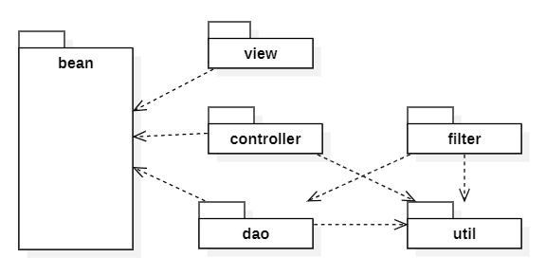

***Code Packages***

|  |  |  |
| --- | --- | --- |
| **No** | **Package** | **Description** |
| 01 | <Package name> | <Description of the package> |
| 02 |  |  |

## 3. System Detailed Design

### 3.1 Register

### *Class diagram*

### *Sequence diagram (s)*

### 3.2 Login

### *Class diagram*

### *Sequence diagram (s)*

### 3.3 Search photographer

### *Class diagram*

### *Sequence diagram (s)*

### 3.4 Get photographer’s detail

### *Class diagram*

### *Sequence diagram (s)*

### 3.5 Book photographer

### *Class diagram*

### *Sequence diagram* *(s)*

### 3.6 Review photographer

### 3.7 Get booking (cancel, edit, accept, decline)

### *Class diagram*

### *Sequence diagram (s)*

### 3.8 Edit working calendar

### *Class diagram*

### *Sequence diagram (S)*

### 3.9 Get customer’s review

### *Class diagram*

### *Sequence diagram (s)*

### 3.10 Manage service (add, edit, remove)

### *Class diagram*

### *Sequence diagram (s)*

### 3.11 Manage album (add, edit, remove)

### *Class diagram*

### *Sequence diagram (s)*

### 3.12 Manage user (add, edit, remove)

### *Class diagram*

### *Sequence diagram (s)*

### 3.13 Manage shooting category (add, edit, remove)

### 3.14 Get profile (edit profile)

### 3.15 Logout

### 3.16 Change password

#### a. Class Diagram

**Figure 2- Class diagram**

#### b. Sequence Diagram(s)

*[Provide the sequence diagram(s) for the feature, see the sample below]*

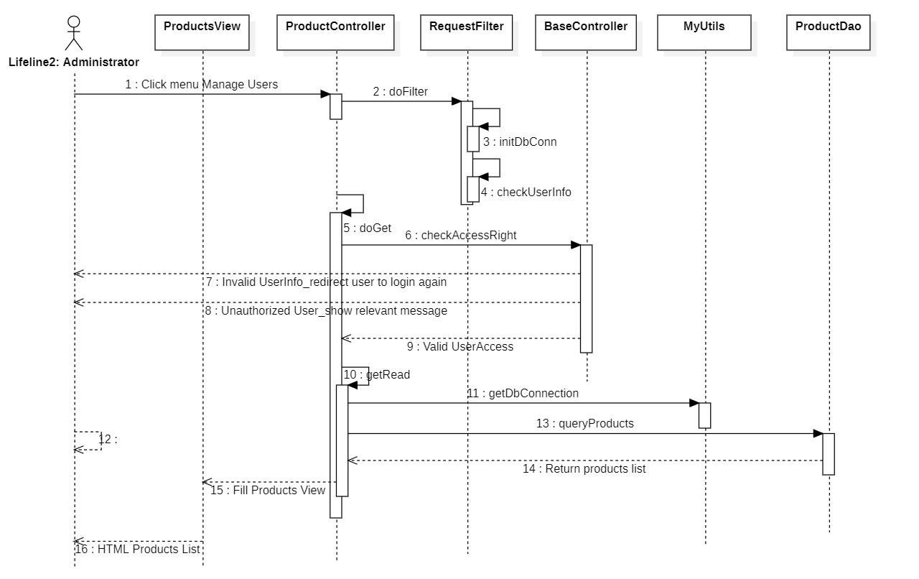

## 4. Class Specifications

### 4.1 XYZ Class

*[Provide the detailed description for the class methods]*

|  |  |  |
| --- | --- | --- |
| **No** | **Method** | **Description** |
| 01 | <method name> | <Description of the method, including the inputs, outputs & internal method processing> |
|  |  |  |

### 4.2 ABC Class

***Class Methods***

*[Provide the detailed description for the class methods]*

|  |  |  |
| --- | --- | --- |
| **No** | **Method** | **Description** |
| 01 | <method name> | <Description of the method, including the inputs, outputs & internal method processing> |
|  |  |  |

### 4.3 …

## 5. Data & Database Design

### 5.1 Database Design

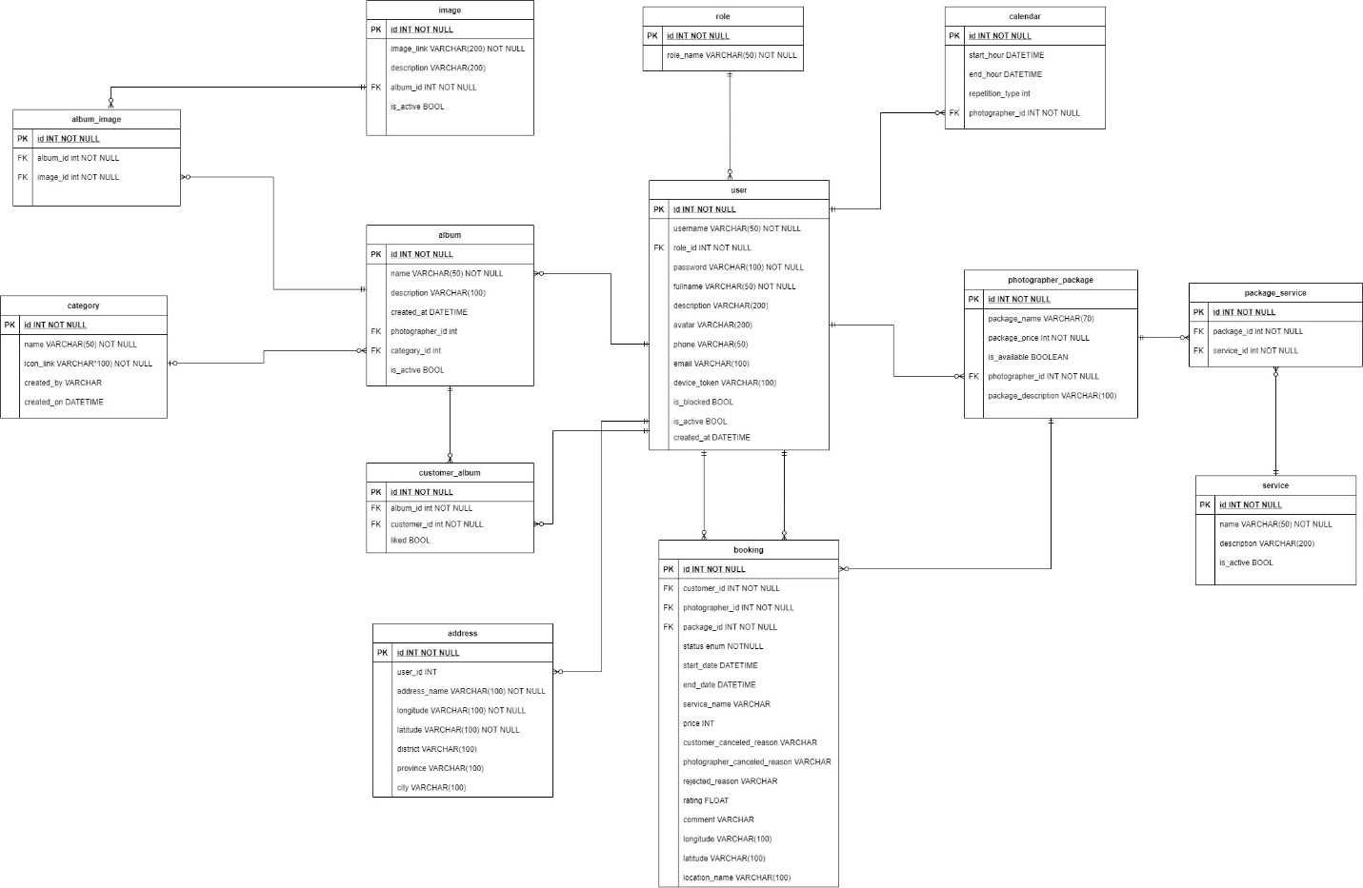

**Figure 3 – Database design**

#### User

|  |  |  |  |  |  |  |  |
| --- | --- | --- | --- | --- | --- | --- | --- |
| **#** | **Field name** | **Type** | **Size** | **Unique** | **Not Null** | **PK/FK** | **Notes** |
| 1 | id | int |  | X | X | X |  |
| 2 | username | varchar | 50 | X | X |  |  |
| 3 | password | varchar | 100 |  | X |  |  |
| 4 | fullname | varchar | 50 |  | X |  |  |
| 5 | description | varchar | 200 |  |  |  |  |
| 6 | avatar | varchar | 200 |  |  |  | Avatar image link of user |
| 7 | phone | varchar | 50 |  |  |  |  |
| 8 | email | varchar | 100 |  |  |  |  |
| 9 | device_token | varchar | 100 |  |  |  | The firebase token of device, using for firebase messaging. |
| 9 | is_blocked | boolean |  |  |  |  |  |
| 10 | is_active | boolean |  |  |  |  |  |
| 11 | created_at | datetime |  |  |  |  |  |
| 12 | role_id | int |  |  | X | X |  |

#### Role

|  |  |  |  |  |  |  |  |
| --- | --- | --- | --- | --- | --- | --- | --- |
| **#** | **Field name** | **Type** | **Size** | **Unique** | **Not Null** | **PK/FK** | **Notes** |
| 1 | id | int |  | X | X | X |  |
| 2 | role_name | varchar | 50 |  | X |  |  |

#### Photographer-Package

|  |  |  |  |  |  |  |  |
| --- | --- | --- | --- | --- | --- | --- | --- |
| **#** | **Field name** | **Type** | **Size** | **Unique** | **Not Null** | **PK/FK** | **Notes** |
| 1 | id | int |  | X | X | X |  |
| 2 | package_name | varchar | 70 |  | X |  |  |
| 3 | package_price | int |  |  | X |  |  |
| 4 | is_available | boolean |  |  |  |  |  |
| 5 | package _description | varchar | 100 |  |  |  |  |
| 6 | photographer _id | int |  |  | X | X |  |

#### Package-Service

|  |  |  |  |  |  |  |  |
| --- | --- | --- | --- | --- | --- | --- | --- |
| **#** | **Field name** | **Type** | **Size** | **Unique** | **Not Null** | **PK/FK** | **Notes** |
| 1 | id | int |  | X | X | X |  |
| 2 | package_id | int |  |  | X | X |  |
| 3 | service_id | int |  |  | X | X |  |

#### Service

|  |  |  |  |  |  |  |  |
| --- | --- | --- | --- | --- | --- | --- | --- |
| **#** | **Field name** | **Type** | **Size** | **Unique** | **Not Null** | **PK/FK** | **Notes** |
| 1 | id | int |  | X | X | X |  |
| 2 | name | varchar | 50 |  | X |  |  |
| 3 | description | varchar | 200 |  |  |  |  |
| 4 | is_active | boolean |  |  |  |  |  |

#### Booking

|  |  |  |  |  |  |  |  |
| --- | --- | --- | --- | --- | --- | --- | --- |
| **#** | **Field name** | **Type** | **Size** | **Unique** | **Not Null** | **PK/FK** | **Notes** |
| 1 | id | int |  | X | X | X |  |
| 2 | status | enum |  |  | X |  | There will be 6 status: Pending, Ongoing, Editing, Done, Rejected, Canceled |
| 3 | start_date | datetime |  |  | X |  |  |
| 4 | end_date | datetime |  |  | X |  |  |
| 5 | service_name | varchar | 100 |  | X |  | Package’s name |
| 6 | price | int |  |  | X |  | Package’s price |
| 7 | customer  _canceled  _reason | varchar | 100 |  |  |  | In case customers cancel and provide their reason |
| 8 | photographer _canceled _reason | varchar | 100 |  |  |  | In case photographers cancel and provide their reason |
| 9 | rejected_reason | varchar | 100 |  |  |  | In case photographers reject the request and provide reason |
| 10 | rating | float |  |  |  |  | After booking is done, customer can rate the booking |
| 11 | comment | varchar | 100 |  |  |  | After booking is done, customer can comment on the booking |
| 12 | longitude | varchar | 100 |  |  |  |  |
| 13 | latitude | varchar | 100 |  |  |  |  |
| 14 | location_name | varchar | 100 |  |  |  | The shooting location picked by customer |
| 15 | customer_id | int |  |  | X | X |  |
| 16 | photographer _id | int |  |  | X | X |  |
| 17 | package_id | int |  |  | X | X |  |

#### Album

|  |  |  |  |  |  |  |  |
| --- | --- | --- | --- | --- | --- | --- | --- |
| **#** | **Field name** | **Type** | **Size** | **Unique** | **Not Null** | **PK/FK** | **Notes** |
| 1 | id | int |  | X | X | X |  |
| 2 | name | varchar | 50 |  | X |  |  |
| 3 | description | varchar | 100 |  |  |  |  |
| 4 | created_at | datetime |  |  |  |  |  |
| 5 | is_active | boolean |  |  |  |  |  |
| 6 | photographer _id | int |  |  | X | X |  |
| 7 | category_id | int |  |  |  | X |  |

#### Address

|  |  |  |  |  |  |  |  |
| --- | --- | --- | --- | --- | --- | --- | --- |
| **#** | **Field name** | **Type** | **Size** | **Unique** | **Not Null** | **PK/FK** | **Notes** |
| 1 | id | int |  | X | X | X |  |
| 2 | address_name | varchar | 100 |  | X |  |  |
| 3 | longitude | varchar | 100 |  | X |  |  |
| 4 | latitude | varchar | 100 |  | X |  |  |
| 5 | district | varchar | 100 |  |  |  |  |
| 6 | province | varchar | 100 |  |  |  |  |
| 7 | city | varchar | 100 |  |  |  |  |
| 8 | user_id | int |  |  | X | X |  |

#### Category

|  |  |  |  |  |  |  |  |
| --- | --- | --- | --- | --- | --- | --- | --- |
| **#** | **Field name** | **Type** | **Size** | **Unique** | **Not Null** | **PK/FK** | **Notes** |
| 1 | id | int |  | X | X | X |  |
| 2 | name | varchar | 50 |  | X |  |  |
| 3 | icon_link | varchar | 100 |  | X |  | Link for the icon of category |
| 4 | created_by | varchar | 100 |  |  |  | Name of the admin who created the category |
| 5 | created_at | datetime |  |  |  |  |  |

#### Album-Image

|  |  |  |  |  |  |  |  |
| --- | --- | --- | --- | --- | --- | --- | --- |
| **#** | **Field name** | **Type** | **Size** | **Unique** | **Not Null** | **PK/FK** | **Notes** |
| 1 | id | int |  | X | X | X |  |
| 2 | album_id | int |  |  | X | X |  |
| 3 | image_id | int |  |  | X | X |  |

#### Image

|  |  |  |  |  |  |  |  |
| --- | --- | --- | --- | --- | --- | --- | --- |
| **#** | **Field name** | **Type** | **Size** | **Unique** | **Not Null** | **PK/FK** | **Notes** |
| 1 | id | int |  | X | X | X |  |
| 2 | image_link | varchar | 200 |  | X |  |  |
| 3 | description | varchar | 200 |  |  |  |  |
| 4 | is_active | boolean |  |  |  |  |  |
| 5 | album_id | int |  |  | X | X |  |

#### Customer-Album

|  |  |  |  |  |  |  |  |
| --- | --- | --- | --- | --- | --- | --- | --- |
| **#** | **Field name** | **Type** | **Size** | **Unique** | **Not Null** | **PK/FK** | **Notes** |
| 1 | id | int |  | X | X | X |  |
| 2 | liked | boolean |  |  |  |  | represent if customer has liked the album |
| 3 | album_id | int |  |  | X | X |  |
| 4 | customer_id | int |  |  | X | X |  |

#### Calendar

|  |  |  |  |  |  |  |  |
| --- | --- | --- | --- | --- | --- | --- | --- |
| **#** | **Field name** | **Type** | **Size** | **Unique** | **Not Null** | **PK/FK** | **Notes** |
| 1 | id | int |  | X | X | X |  |
| 2 | start_hour | datetime |  |  |  |  |  |
| 3 | end_hour | datetime |  |  |  |  |  |
| 4 | repetition_type | enum |  |  |  |  |  |
| 5 | photographer _id | int |  |  | X | X |  |

### 5.2 Data File Design

We use Aws S3 to store files and images.

|  |  |  |  |
| --- | --- | --- | --- |
| **#** | **File Name** | **Type** | **Notes** |
| 1 | User avatar | Image | uri: “/{userId}/{userId}-avatar” |
| 2 | Photographer album thumbnail | Image | uri: “/{ptgId}/{ptgId}/{albumid}/{albumId}-thumbnail” |
| 3 | Photographer album image | Image | uri: “/{ptgId}/{ptgId}/{albumid}/{albumId}/{imageId}-image” |
| 4 | Photographer cover image | Image | uri: “/{ptgId}/{ptgId}-cover” |
| 5 | Category icon image | Image | uri: “/categories/{categoryId}-category” |